Turning up the heat: safety tips

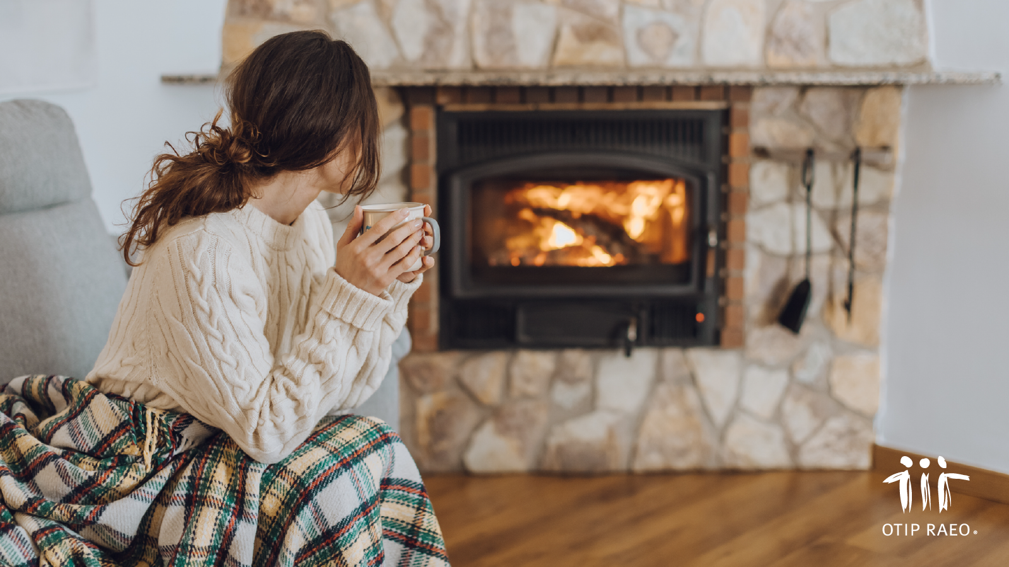

There’s nothing like a home that’s toasty and warm when the temperature starts to drop. But there are precautions to take in order to heat safely. Here are some handy tips to avoid ending up… in hot water.

Read more at [www.otip.com/article175](https://www.otip.com/article175). #OTIPUpdate